

**Dynamics 365 – Vendor Creation**

**Revision 1**

**Revision History**

|  |  |  |  |  |
| --- | --- | --- | --- | --- |
| **Date** | **Revision** | **Description** | **Signature / Date** | |
| 17/06/2022 | 1 | Initial draft of user manual: Dynamics 365 – Vendor Creation | Prepared | Salman Tahir |
|  |  | Verified |  |
|  |  | Approved |  |
| 04/11/2022 | 2 | User manual: Dynamics 365 – Vendor Creation | Prepared | Waseem Abbas |
|  |  | Verified |  |
|  |  | Approved |  |
|  |  |  | Prepared |  |
|  |  |  |  |
|  |  |  |  |
|  |  |  |  |  |
|  |  |  |  |
|  |  |  |  |

**Table of Contents**

1 About User Manual 5

2 All Vendor Page 5

2.1 New Vendor 5

2.2 Include Vendor General Details 6

2.3 Vendor Address Details 6

2.4 Contact Information Details 7

2.5 Contact 10

2.5.1 Create New Contact 12

2.5.2 Edit Contact 14

2.5.3 Delete Contact 15

2.6 Primary Contact 15

List of Figures

Figure 1 Way to open 'All Vendors' page 5

Figure 2 Vendors from Recoupment and Sources 5

Figure 3 Select 'New' Option 6

Figure 4 Details in the General Section 6

Figure 5 Address Form to Add new Address 7

Figure 6 Address Edit of Vendor 7

Figure 7 Vendor Contact Information Details 8

Figure 8 Vendor Add Contact 8

Figure 9 Vendor Add New Contact 9

Figure 10 Vendor Contact Remove 9

Figure 11 Vendor Contact Edit 10

Figure 12 Vendor Contact Edit Form 10

Figure 13 Vendor Contact 11

Figure 14 Vendor View Contacts 11

Figure 15 Vendor All Contact List with Detail 12

Figure 16 Vendor Create Contact 12

Figure 17 Fields to Create New Contact 13

Figure 18 Create New Contact Information 13

Figure 19 Fill the Fields and Press Save to Create New Contact 13

Figure 20 Vendor Edit Contact 14

Figure 21 Update fields to Edit Contact 14

Figure 22 Delete Selected Contact 15

Figure 23 All Contacts page 15

Figure 24 Contact Creation 16

# About User Manual

This document describes the step-by-step guide for creation of new vendor. It is process to add any vendor which is currently non-existing.

# All Vendor Page

In order to create a new vendor, select the modules option. Go to the Account payable and select ‘**All vendors**’ available under the Vendor sub-option.

**Navigation**: Module> Account payable > Vendors > All vendors

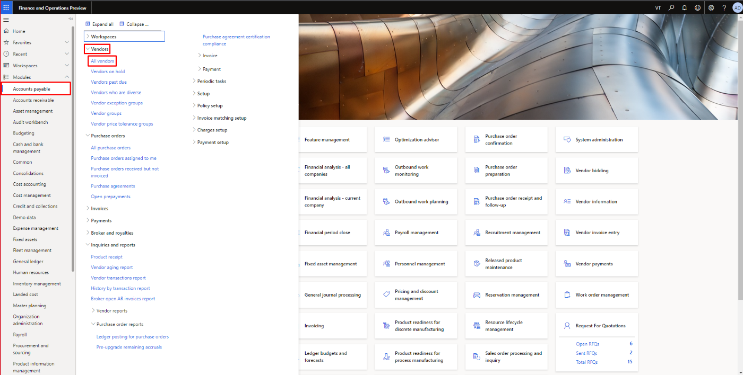

Figure 1 Way to open 'All Vendors' page

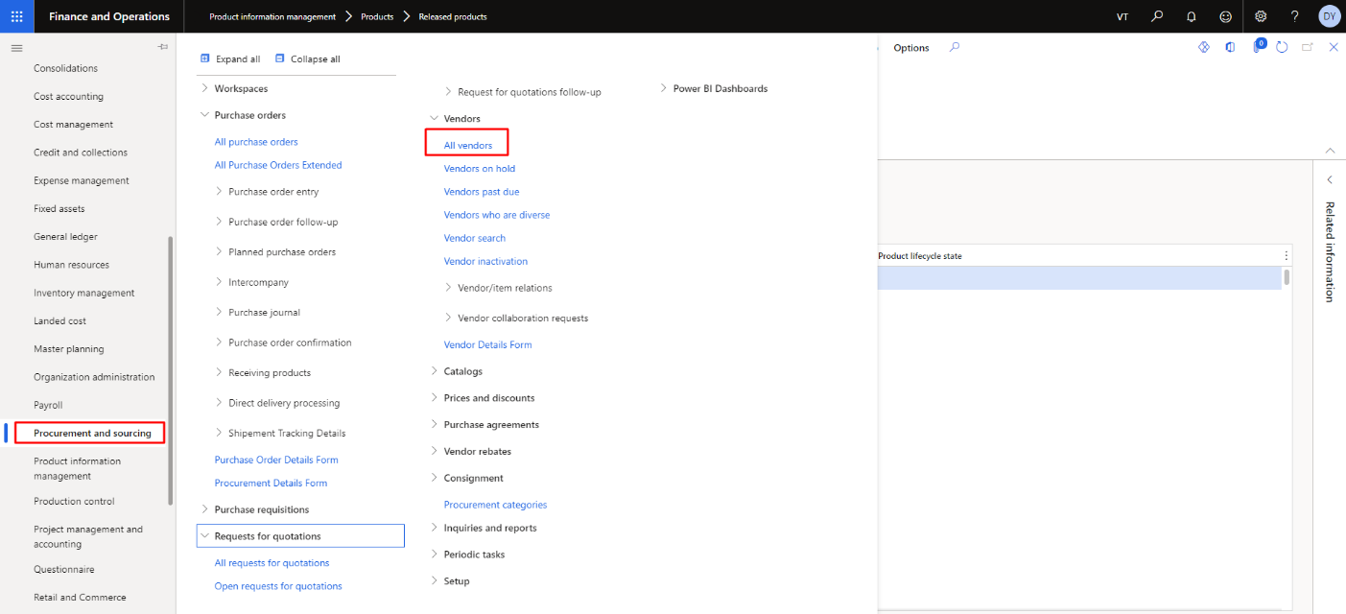

Figure 2 Vendors from Recoupment and Sources

## New Vendor

To create new vendor, select the ‘**New’** option available on the top.

**Navigation**: Vendors > All vendors > New

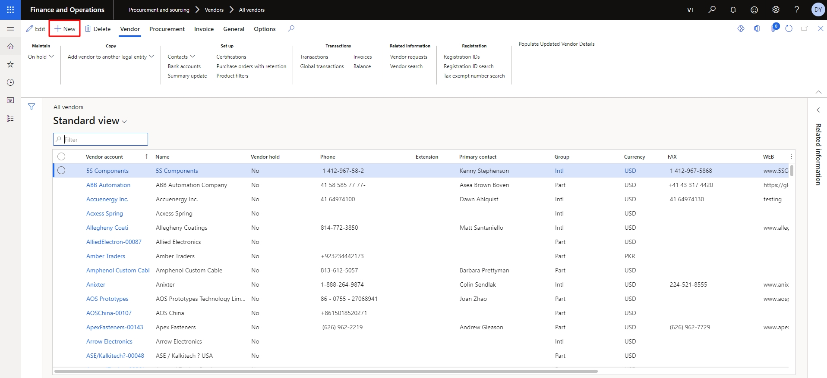

Figure 3 Select 'New' Option

## Include Vendor General Details

Write the authentic vendor details in the general section. Below figure shows the sample vendor account, Name and group fields. **The process is also highlighted in the Figure 04.**

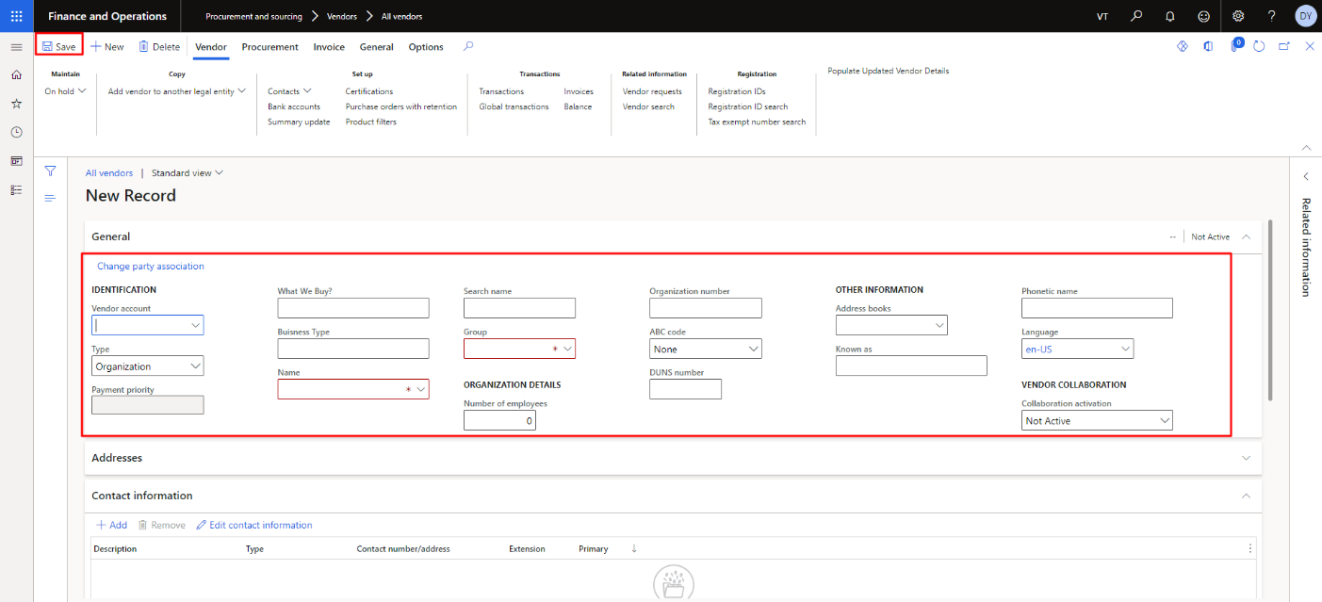

Figure 4 Details in the General Section

## Vendor Address Details

Add the address details of the vendor. Below picture contains the sample address details. **The process is also highlighted in the Figure 05.**

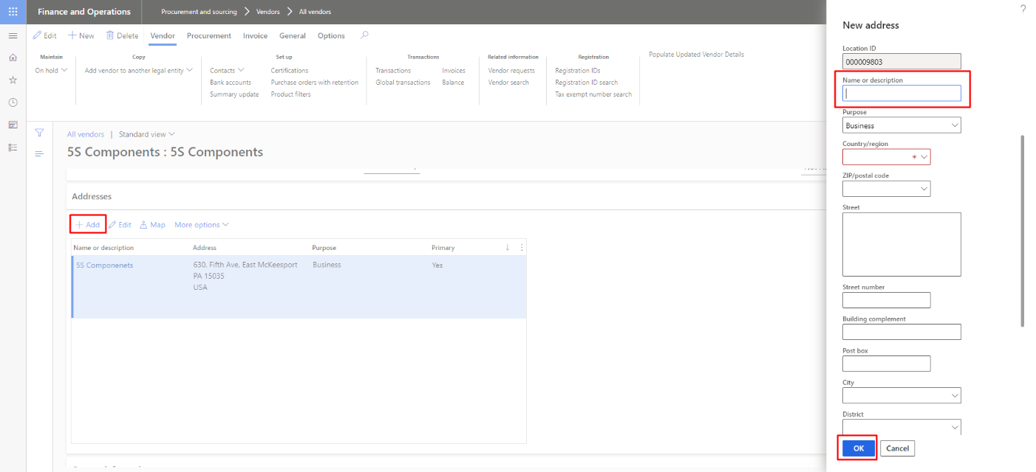

Figure 5 Address Form to Add new Address

The user needs to click on edit button to edit the any selective address of vendor. **The process is also highlighted in the Figure 06.**

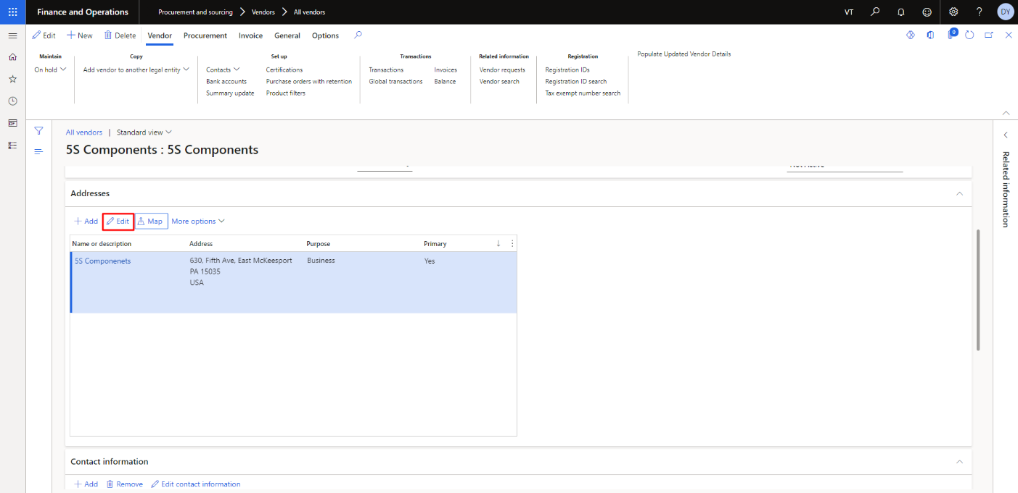

Figure 6 Address Edit of Vendor

## Contact Information Details

Add the contact details of the vendor. Generally, it contains an email address, phone number and website URL. Follow the sample picture below to get an idea. You can also add the primary contact (if available). After adding the details, press on the save button.

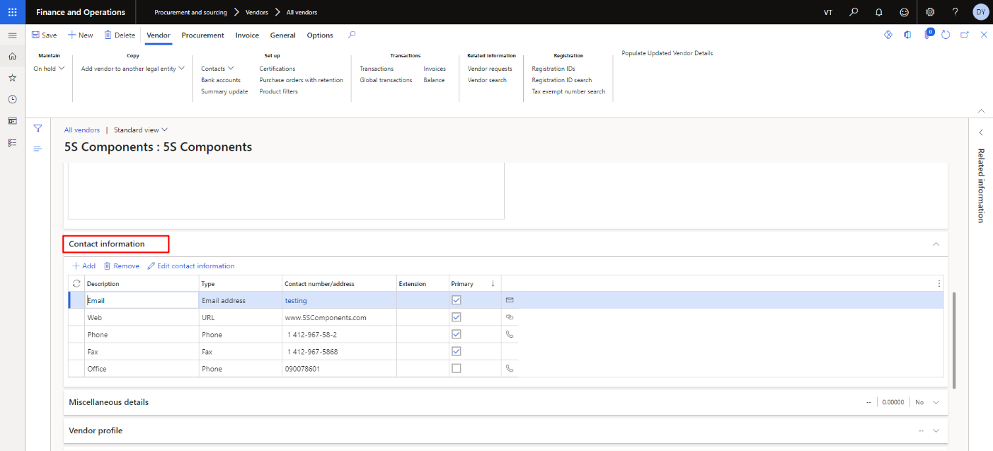

Figure 7 Vendor Contact Information Details

The user needs to click on add button to add the new address of vendor. **The process is also highlighted in the Figure 08.**

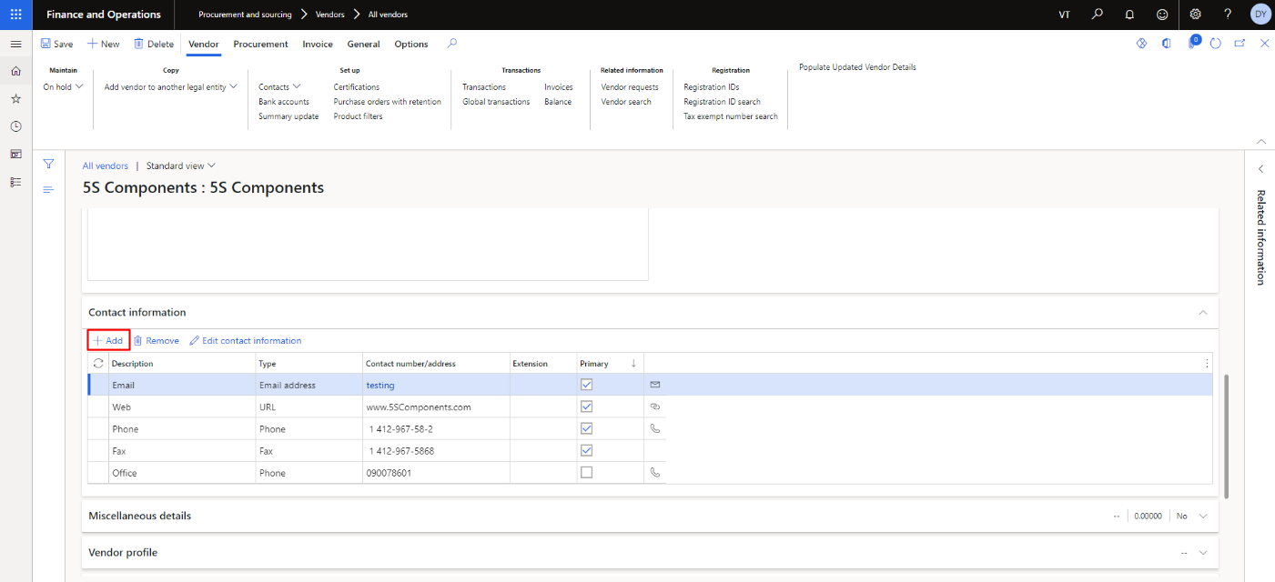

Figure 8 Vendor Add Contact

The user needs to fill the fields and then click on save button to add the new contact detail of the vendor. **The process is also highlighted in the Figure 09.**

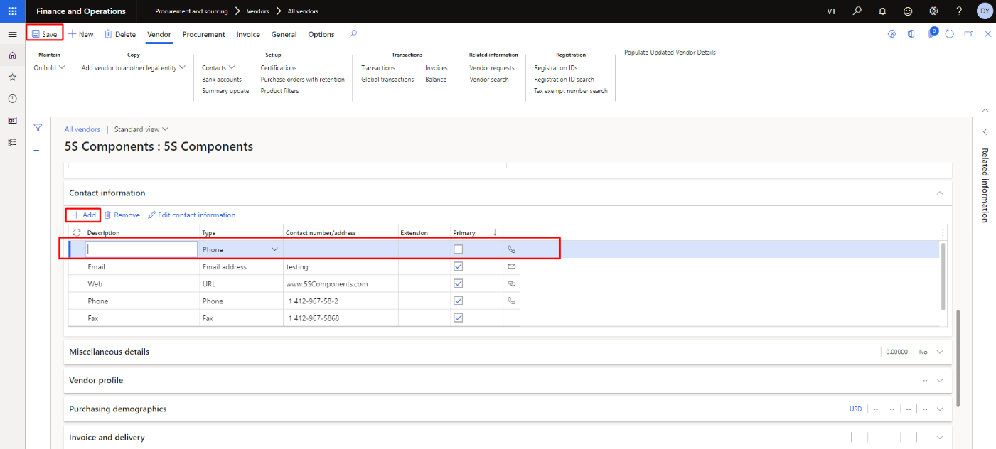

Figure 9 Vendor Add New Contact

The user needs to select the specific contact detail to remove. **The process is also highlighted in the Figure 10.**

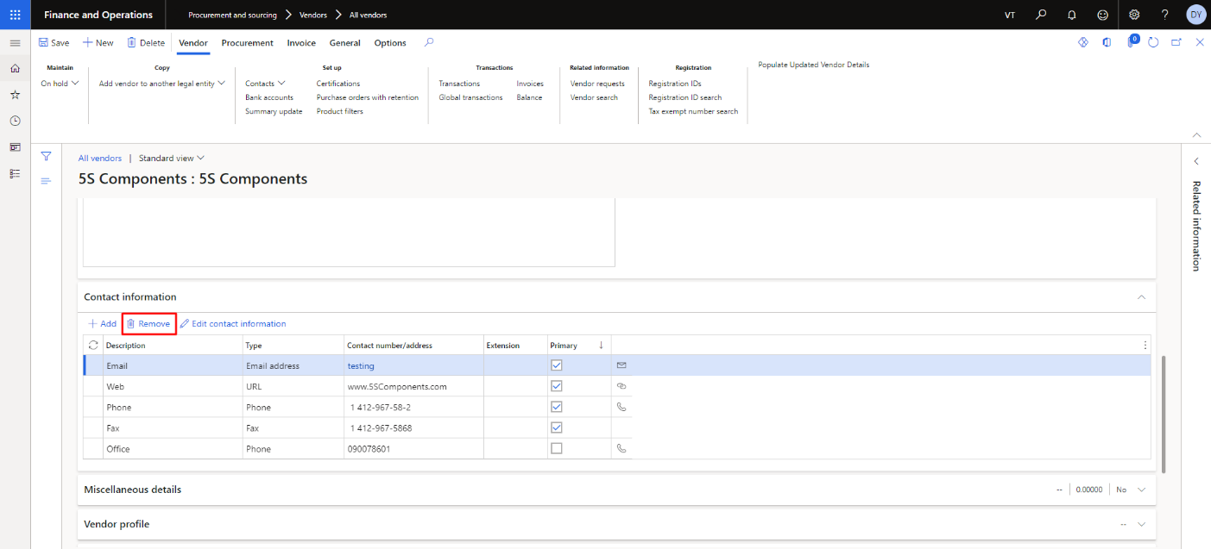

Figure 10 Vendor Contact Remove

The user needs to click on edit button to edit the selective contact detail of vendor. **The process is also highlighted in the Figure 11.**

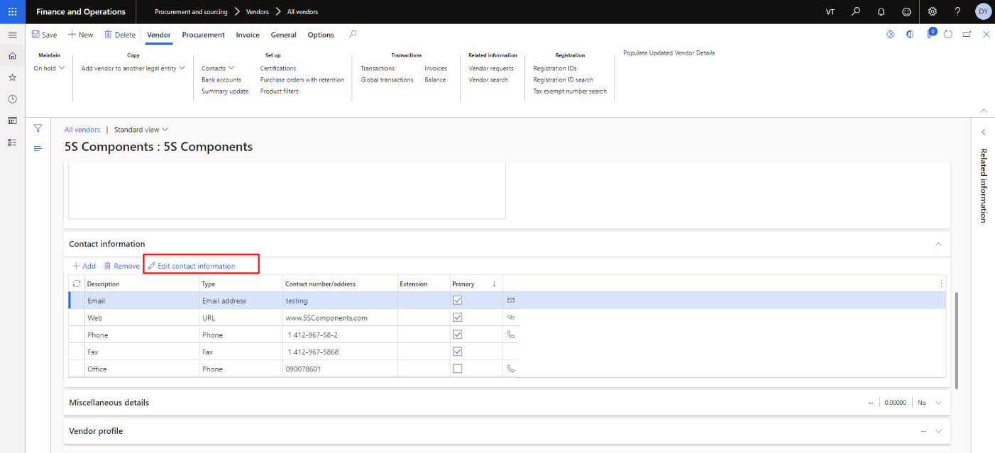

Figure 11 Vendor Contact Edit

The user needs to fill the fields and then click on ok button to update the contact detail of the vendor. **The process is also highlighted in the Figure 12.**

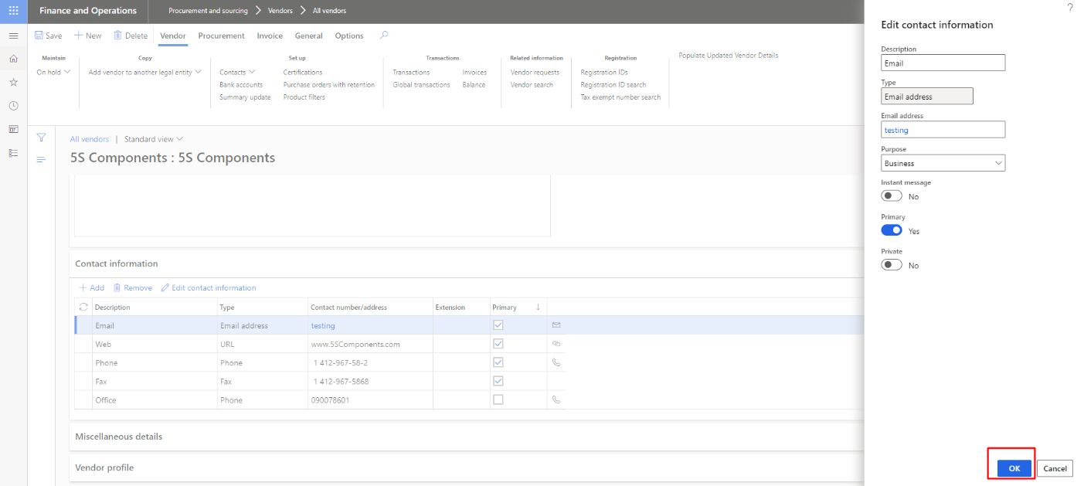

Figure 12 Vendor Contact Edit Form

## Contact Person

The user can view and add new contact of any vendor. The user needs to click on Contact under vendor tab. As the user clicks on it, the dropdown will appear then user need to click on view contact. The user can see the list of the vendor. **The process is also highlighted in the Figure 13, 14 and 15.**

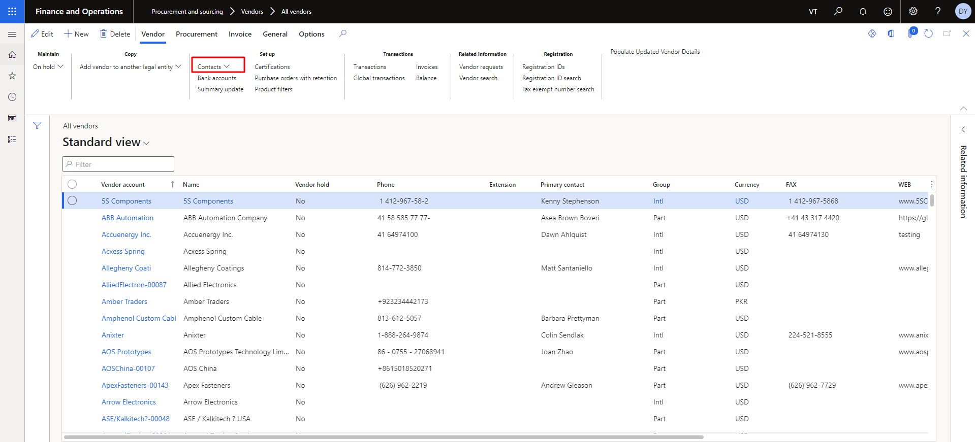

Figure 13 Vendor Contact

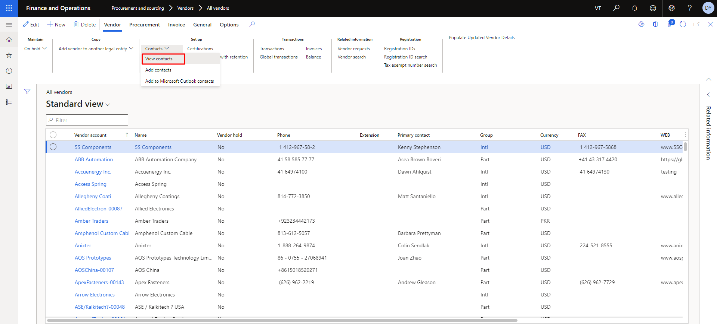

Figure 14 Vendor View Contacts

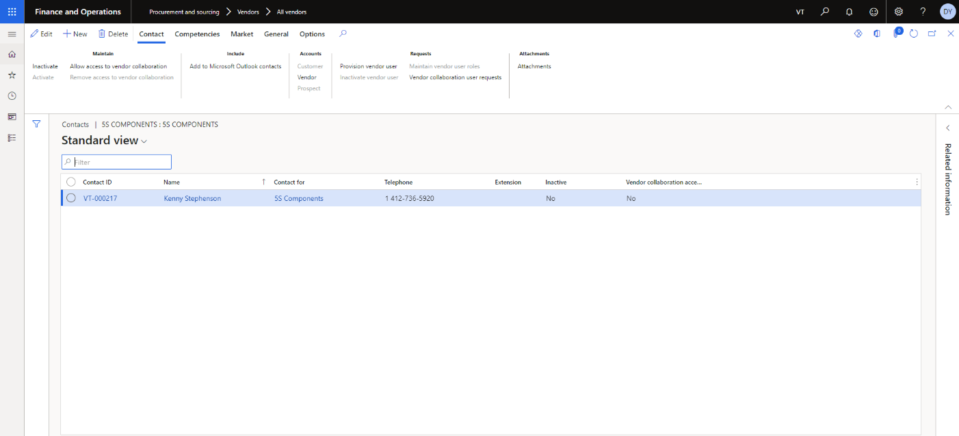

Figure 15 Vendor All Contact List with Detail

### ***Create New Contact***

The user needs to click on NEW in tab to create the new contact. As the user click on New tab user pop will appear with fields, user need to fill the fields to create the new contact and then press on save button. **The process is also highlighted in the Figure 16, 17 and 18.**

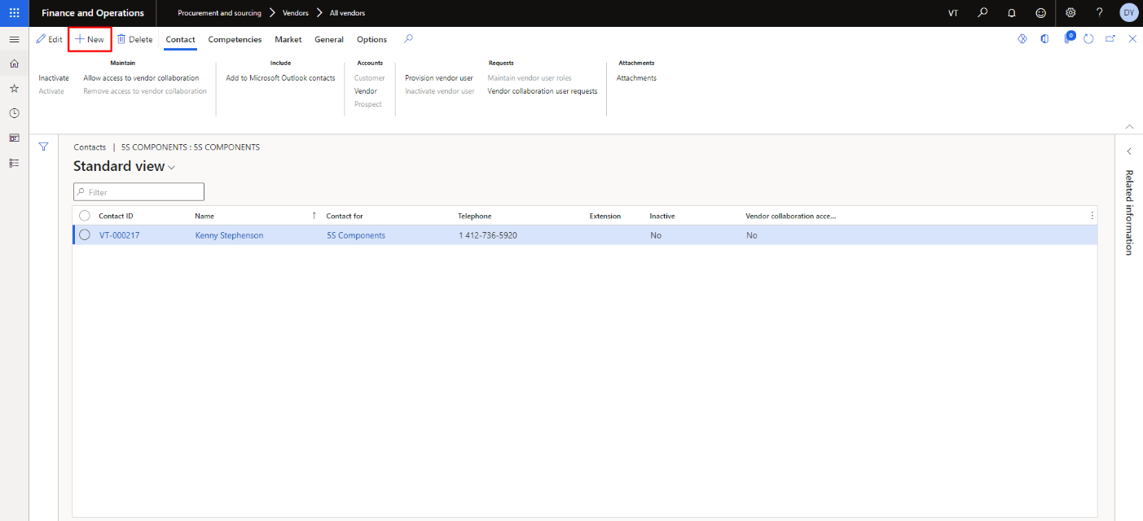

Figure 16 Vendor Create Contact

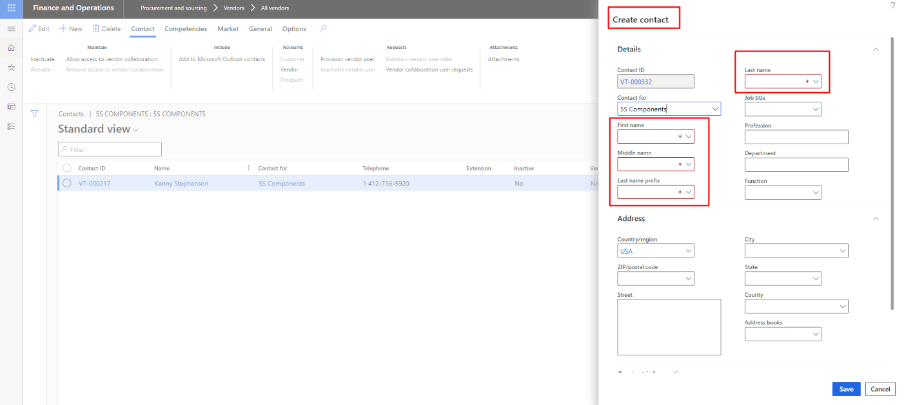

Figure 17 Fields to Create New Contact

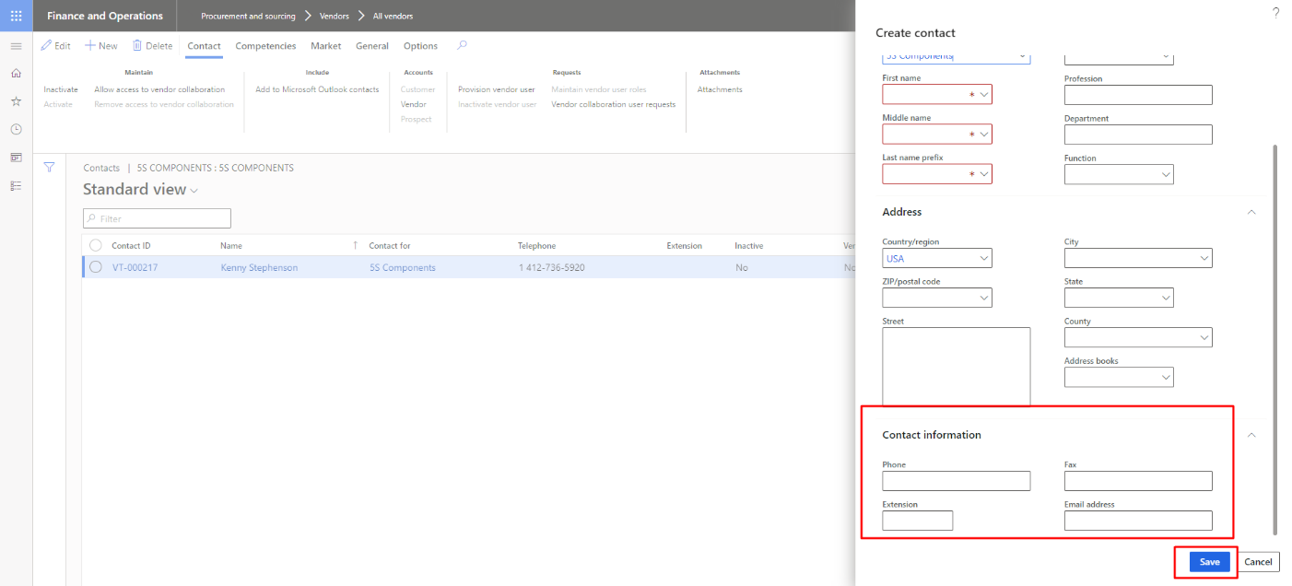

Figure 18 Create New Contact Information

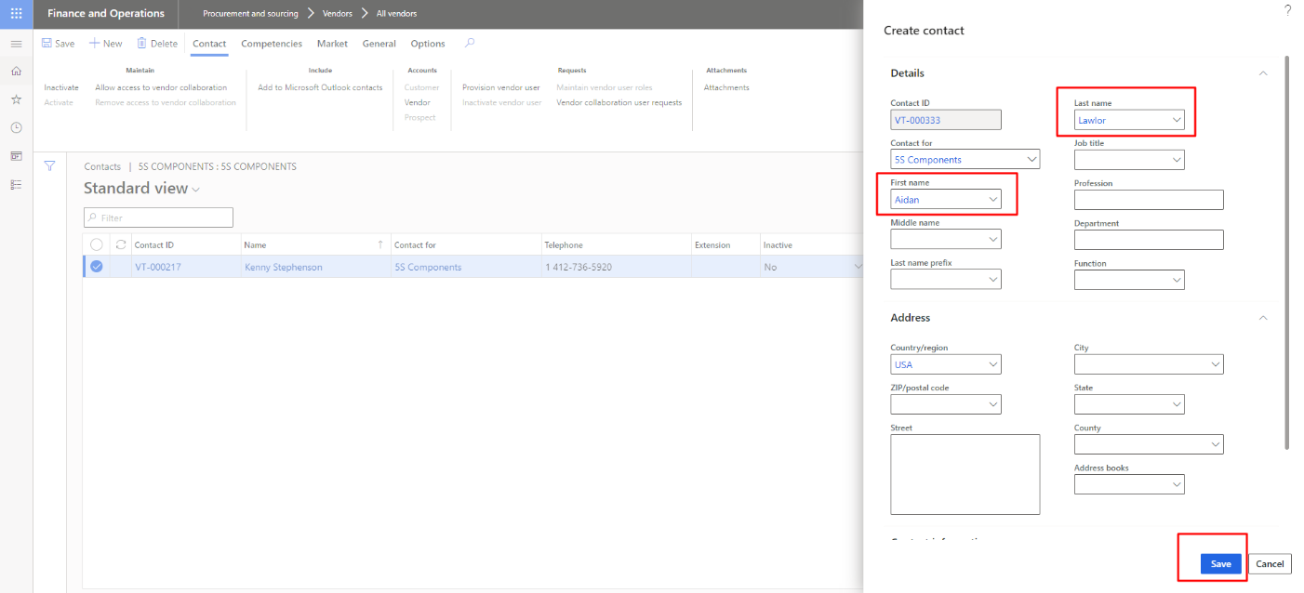

Figure 19 Fill the Fields and Press Save to Create New Contact

### Edit Contact

The user can edit the any contact from the list of contact. The user needs to click on edit button then update the fields as per need to update the contact. **The process is also highlighted in the Figure 19 and 20.**

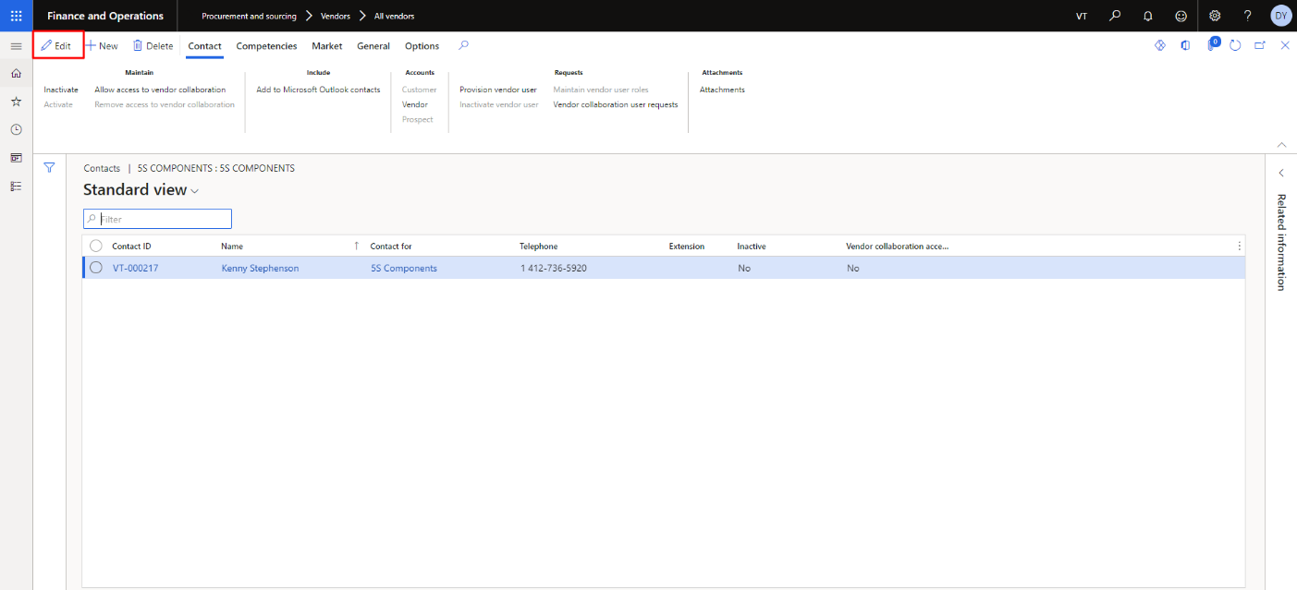

Figure 20 Vendor Edit Contact

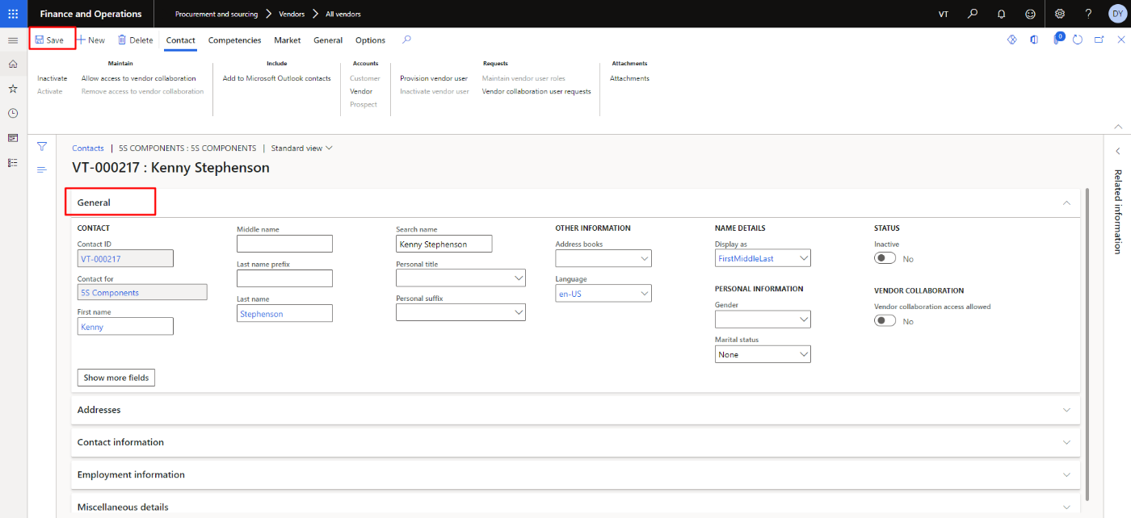

Figure 21 Update fields to Edit Contact

### Delete Contact

The user can delete the any selected contact by clicking on delete button. **The process is also highlighted in the Figure 21**

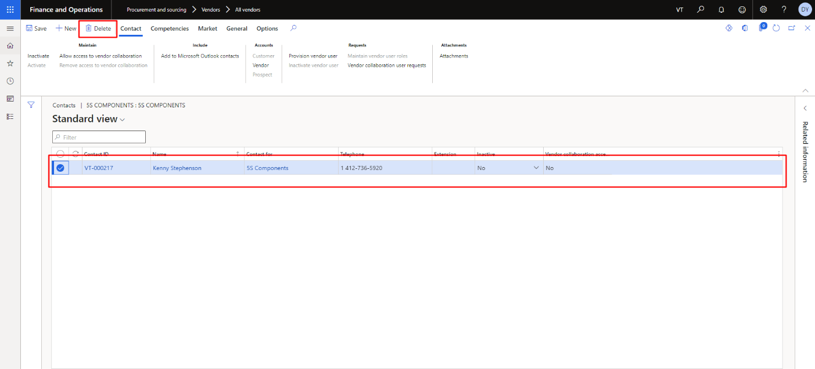

Figure 22 Delete Selected Contact

## Primary Contact

To add the primary contact, create the contact information in the ‘**All Contacts**’ page first. Follow the steps shown in pictures.

**Navigation**: Vendor collaboration > Contacts > All contacts

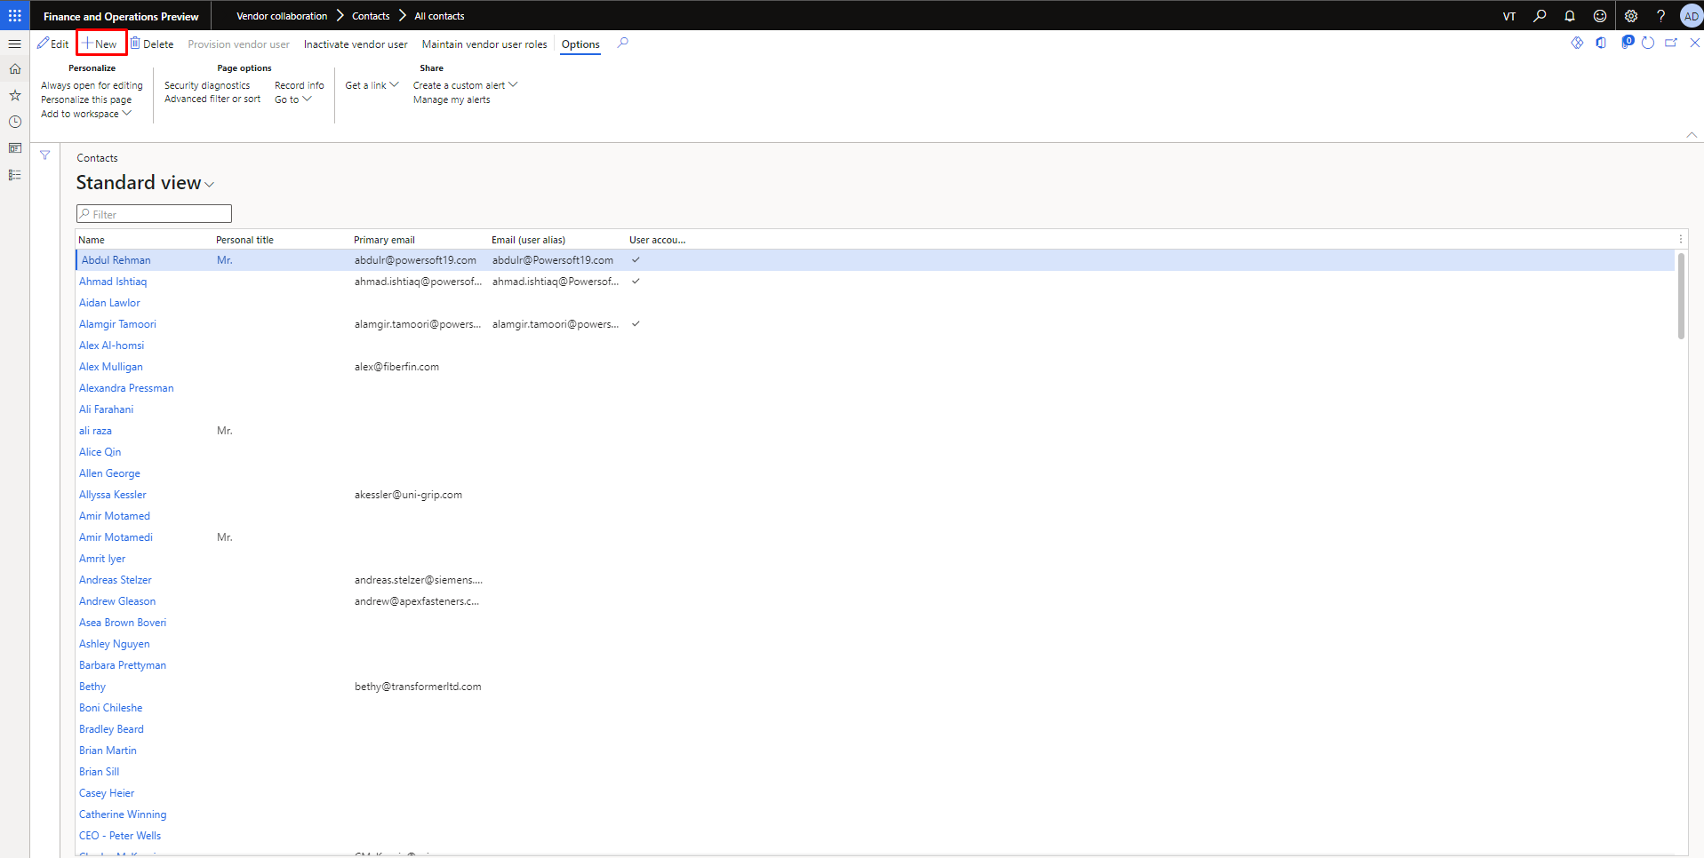

Figure 23 All Contacts page

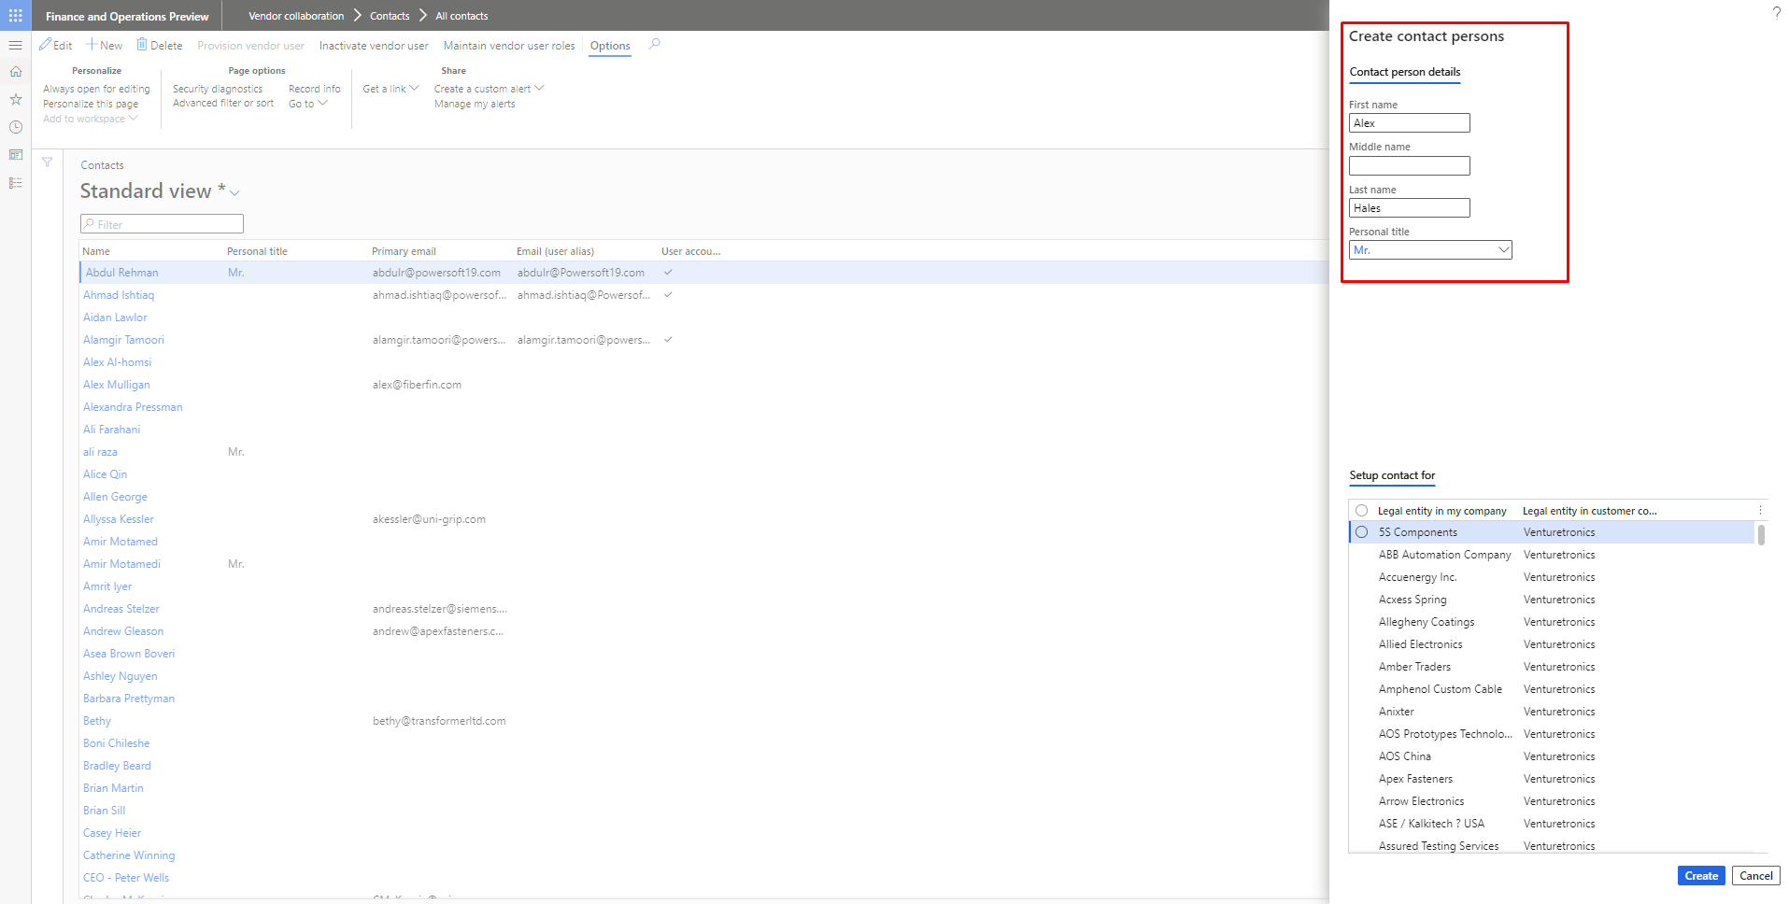

Figure 24 Contact Creation